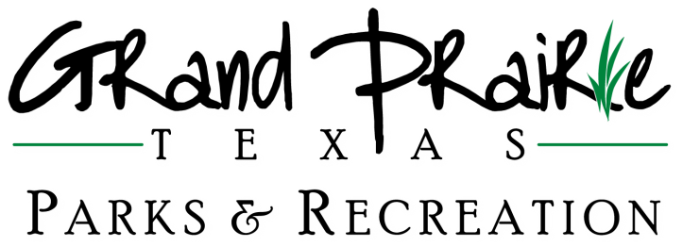
Building and Pavilion Guidelines
NOTICE TO PARK PATRONS

- Reservations must be paid in full the day the reservation is made.
- Your usage permit is valid for the date and time indicated on your permit. The latest any reservation will be booked for pavilions are 2 business days before the rental date and 7 business days for building rentals. Due to facility bookings and frequency 30 days is recommended. Pavilion and/or gazebo rental refunds will NOT be given due to inclement weather.
- 72 hours prior notice is needed for refund on all cancellations for the pavilions. One week prior notice is needed for refund on any and all cancellations for the buildings.
- Any use of materials such as nails, screws, thumbtacks and masking or duct tape are not allowed as they may damage the walls.
- Any items such as confetti balloons, silly string, smoke bombs and paint won’t be allowed to use inside rental space or at outside pavilions.
- Electricity is NOT provided at any outdoor facilities.
- Alcoholic beverages are PROHIBITED in the parks and the buildings.
- NO commercial activity to involve the sale of any items is permitted.
- Amplified sound, music and speech are PROHIBITED in park.
- To report facility or rental problems call 972-237-8350 and leave a detailed message with your phone number. An on-call employee will call you back.
- In case of an emergency, please call 911..
- Responsible party is LIABLE for damages to facility and equipment during the rental.
- The Special Use permit must be displayed or be available at your event or activity.

Restrooms in the parks are closed for winterization, December-February, with the exceptions of Mike Lewis and Friendship, which are closed only during inclement weather.

NOTICIAS PARA PATRONS DE LOS PARQUES

- Su permiso es valido solamente para el tiempo y dia indicado
- Reservaciones deben pagarse en su totalidad el día en que se realiza la reserva.
- Se PROHIBE la venta/consumo de bebidas alcoholicas en los parques y salones que se encuentran en los parques.
- NO SE PERMITE actividad commercial que envuelva la venta de ningun articulo.
- Se PROHIBE ruidos excesivos incluyendo musica y discursos en los parques y salones.
- Para obtener un rembolso, se require 72 hours de aviso.
- No se ofrece electricidad en ningun parque.
- En caso de emergencia, llame a la policia 911.
- La persona que contrata es responsable por los danos que causen durante la renta del parque o salones.
- Para reportar un problema, llame al 972-237-8350 y deje un mensaje detallado con su número de teléfono. Un empleado le devolverá la llamada.
- No hay rembolso por causa de mal tiempo.
- El Permiso de Uso Especial debe ser mostrado o estar disponible en su actividad o evento.

Los banos en los parques estaran cerados durante los meses de Dicembre, Enero, y Febrero, on las excepciones de Mike Lewis y Friendship, que están cerrados solo durante las inclemencias del tiempo.

